Genetic algorithm rule based classification

William Blackie, Student Number: 16011054

1 INTRODUCTION
Concise description of task asked and your approach(es).
2 BACKGROUND RESEARCH
Rule-based representations have been used in data mining in many ways. Give a brief summary of some recent examples you can find, connecting them to your assignment perhaps too. Use clear referencing and avoid including material directly unless carefully indicated as from another source. Half to a whole page expected.
3 EXPERIMENTATION

3.1 Data Set 1
Describe your basic algorithm so anyone who knows about basic GAs could hopefully repeat what you have done. Describe the representation, the parameters, the fitness calculation, etc.

Present your results as averaged behaviour over more than one run, eg (graph not of assignment):
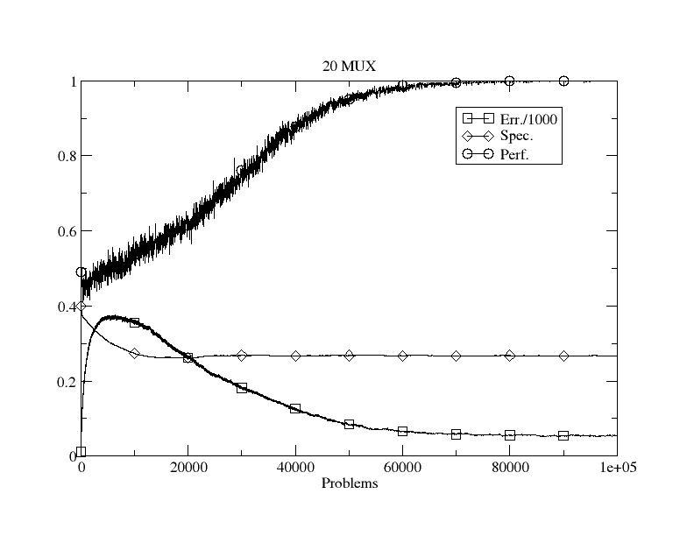
Figure 1: Initial performance on dataset 1.

Show the effects of varying parameters and give potential explanations as to why the behaviour/performance changes. Eg vary the mutation rate or population size. The benefit of rules is that you can examine the structure of the learned model – what is the structure here?

3.2 Data Set 2
If not in the previous section, this should include how you allow generalisation in the representation. Again, show results from varying parameters/aspects and explain them. The use of evolution to learn how many rules to use would be good to include here and/or other modifications. The structure?

3.3 Data Set 3 (and UCI, etc data)
Clearly describe how you changed the representation to deal with real-valued data. And then present results from its use, with graphs and explanations.

For the very keen, it would be great to see comparative performance on the UCI dataset too and/or the use of another representation scheme, eg, neural networks, or use of Weka, etc.
4 CONCLUSIONS
Concise summary of what you found and learned. Identification of ways you might do things differently next time, and why.
REFERENCES
Author, A. (1970) The best way to do AI ever. IEEE Transactions on Data Mining 1(1): 209-238.

And please include either a link to your source code so that more than one person can access it over the next few months or as a full listing in an Appendix. The second marker and external examiner need to be able to see what you actually produced.

